"Advanced Techniques for LFM and NLFM Signal Cancellation in Radar Systems: Theory,
Simulation, and Practical Implementation"
Author: Erfan Ali Akbar
Affiliation: Islamic Azad University, Science and Research Branch, Tehran, Iran
Date: 2024

Abstract1

—Recently, commercial off-the-shelf (COTS) components have become increasingly popular in Synthetic Aperture Radar (SAR) applications. The computational power of these components has advanced to the point where real-time processing of complex SAR algorithms is now achievable. This paper examines the capabilities of a low-power, multi-core Digital Signal Processor (DSP) from Texas Instruments Inc. for SAR signal processing. The DSP in question, the TMS320C6678, is an eight-core processor that delivers a peak performance of 128 GFLOPS (single precision) while consuming only 10 watts. We detail how fundamental SAR operations can be effectively implemented on this device. Our findings show that a standard SAR range-Doppler algorithm processes a 16 M (4K × 4K) image in approximately 0.25 seconds, thus achieving real-time performance.
Source: Wang, D., & Ali, M. (Year). Synthetic Aperture Radar on Low Power Multi-Core Digital Signal Processor. Texas Instruments, Dallas, TX, USA.

ABSTRACT2

—Marine radar clutter statistics are non-stationary, making it difficult for traditional CFAR processors to perform effectively, especially with clutter types like lognormal, Pareto, and K distributions. This paper introduces the Comp-CFAR method, which uses the central limit theorem and logarithmic compression to enhance CFAR robustness. Experimental results show that Comp-CFAR outperforms NCI-CFAR in four typical clutter environments.
Source: Liu, Y., Zhang, S., Suo, J., Zhang, J., & Yao, T. (Year). Research on a New Comprehensive CFAR (Comp-CFAR) Processing Method. Institute of Information Science and Technology, Dalian Maritime University, Dalian 116026, China.

ABSTRACT3
Radar target detection involves estimating target range and velocity using the received echo signal, while Direction of Arrival (DoA) is estimated using separate processing of linear and planar arrays. This paper introduces a radar signal processing algorithm for accurate estimation of target range and Doppler shift, validated through computer simulations. Moreover, it evaluates various DoA estimation algorithms based on computational complexity and performance, offering valuable insights for radar and antenna system designers.
Source: Baig, N. A., & Hussain, A. (Year). RADAR Signal Processing for Target Range, Doppler, and DoA Estimation. International Islamic University, Islamabad, Pakistan & CESAT Islamabad.

ABSTRACT4

This paper introduces a system for actively canceling linear and nonlinear frequency modulated radar signals by manipulating amplitude and phase to produce a signal that opposes radar echoes. The study explores active cancellation stealth theory and provides radar detection probability equations based on Swerling I and III models. Simulation results confirm the potential effectiveness of active cancellation in reducing radar detection probability.
Source: Yi, M., Wang, L., & Huang, J. (2015). Active cancellation analysis based on radar detection probability.

1. Introduction
The techniques for reducing the radar cross section (RCS) of aircraft are generally categorized into four major areas: material selection and coating, target shaping, passive cancellation, and active cancellation. Among these methods, active cancellation stealth represents a significant and evolving field of research. Unlike traditional stealth techniques, which primarily focus on minimizing the radar cross section through passive means, active cancellation aims to further decrease the radar detection probability by generating signals that destructively interfere with the radar returns from the target. The feasibility and effectiveness of active cancellation have been greatly enhanced by advancements in high-speed microelectronic devices, phased-array antenna technologies, and sophisticated computational processing.
In free space, two signals can generate coherent interference, which can either weaken or strengthen the resulting synthesized signal. This principle is at the core of signal cancellation research. Historically, considerable attention has been given to the cancellation of radar interference signals or clutter, acoustic signals, and linear frequency modulation (LFM) pulse compression signals. LFM pulse compression signals are widely used in modern radar systems due to their range resolution capabilities. Nonlinear frequency modulation (NLFM) signals, which involve continuous phase coding with a non-constant sweep rate, are also employed in various radar applications. Consequently, interference effects on LFM and NLFM radar signals have become a critical focus of contemporary electronic warfare research.
The foundational work on the probability of radar detection for constant target reflections was pioneered by Marcum. His models provided the earliest expressions for detection probability, which were later extended by Swerling. Swerling introduced models that account for target fluctuation, offering a more realistic representation of detection scenarios. He proposed four distinct models that have been further generalized using a parameterized gamma distribution. These models have become essential tools for evaluating radar performance and designing countermeasures.
This paper presents an in-depth analysis of a cancellation system tailored for both LFM and three types of NLFM signals: the Taylor window, a combination of LFM and Tangent-FM, and the Stepped NLFM waveform. The proposed system leverages the radar cross section characteristics of targets, modulating the amplitude and phase to generate a signal with the same frequency as the radar echo but with an opposite phase. This technique effectively cancels the radar echo signal, thereby reducing the target's radar detection probability.
The analysis includes the derivation of formulas for radar detection probability under two types of radar target fluctuation models, Swerling I and Swerling III. These models provide a framework for understanding the impact of various factors, such as amplitude, phase, and frequency errors, on detection probability. Through extensive simulations, the study demonstrates that active cancellation stealth technology is theoretically feasible and can significantly lower radar detection probabilities.
The radar detection probability is a function of several parameters, including the signal-to-noise ratio (SNR), threshold multiplier, and false alarm probability (Pfa). For the Swerling I model, the detection probability can be expressed as a function of these parameters, incorporating the Rayleigh probability distribution to model target fluctuations. The study extends this analysis to the Swerling III model, which accounts for more complex target behavior and provides a more comprehensive understanding of radar detection dynamics.
In summary, this paper contributes to the field of electronic warfare by presenting a robust framework for active cancellation stealth. It combines theoretical analysis with practical simulations to validate the effectiveness of the proposed cancellation system. By exploring the interaction between LFM and NLFM signals and various radar detection models, the study offers valuable insights into the development of advanced stealth technologies and their potential applications in modern radar systems

2. Introduction (The techniques for reducing the radar cross section (RCS) of aircraft are generally categorized into four major areas: material selection and coating, target shaping, passive cancellation, and active cancellation. Among these methods, active cancellation stealth represents a significant and evolving field of research. Unlike traditional stealth techniques, which primarily focus on minimizing the radar cross section through passive means, active cancellation aims to further decrease the radar detection probability by generating signals that destructively interfere with the radar returns from the target. The feasibility and effectiveness of active cancellation have been greatly enhanced by advancements in high-speed microelectronic devices, phased-array antenna technologies, and sophisticated computational processing.
In free space, two signals can generate coherent interference, which can either weaken or strengthen the resulting synthesized signal. This principle is at the core of signal cancellation research. Historically, considerable attention has been given to the cancellation of radar interference signals or clutter, acoustic signals, and linear frequency modulation (LFM) pulse compression signals. LFM pulse compression signals are widely used in modern radar systems due to their range resolution capabilities. Nonlinear frequency modulation (NLFM) signals, which involve continuous phase coding with a non-constant sweep rate, are also employed in various radar applications. Consequently, interference effects on LFM and NLFM radar signals have become a critical focus of contemporary electronic warfare research.
The foundational work on the probability of radar detection for constant target reflections was pioneered by Marcum. His models provided the earliest expressions for detection probability, which were later extended by Swerling. Swerling introduced models that account for target fluctuation, offering a more realistic representation of detection scenarios. He proposed four distinct models that have been further generalized using a parameterized gamma distribution. These models have become essential tools for evaluating radar performance and designing countermeasures.
This paper presents an in-depth analysis of a cancellation system tailored for both LFM and three types of NLFM signals: the Taylor window, a combination of LFM and Tangent-FM, and the Stepped NLFM waveform. The proposed system leverages the radar cross section characteristics of targets, modulating the amplitude and phase to generate a signal with the same frequency as the radar echo but with an opposite phase. This technique effectively cancels the radar echo signal, thereby reducing the target's radar detection probability.
The analysis includes the derivation of formulas for radar detection probability under two types of radar target fluctuation models, Swerling I and Swerling III. These models provide a framework for understanding the impact of various factors, such as amplitude, phase, and frequency errors, on detection probability. Through extensive simulations, the study demonstrates that active cancellation stealth technology is theoretically feasible and can significantly lower radar detection probabilities.
The radar detection probability is a function of several parameters, including the signal-to-noise ratio (SNR), threshold multiplier, and false alarm probability (Pfa). For the Swerling I model, the detection probability can be expressed as a function of these parameters, incorporating the Rayleigh probability distribution to model target fluctuations. The study extends this analysis to the Swerling III model, which accounts for more complex target behavior and provides a more comprehensive understanding of radar detection dynamics.

Linear Frequency Modulation (LFM) and Nonlinear Frequency Modulation (NLFM) Signals
Linear Frequency Modulation (LFM) signals, characterized by a linearly changing frequency over time, are extensively used in radar systems for their superior range resolution and Doppler tolerance. The linear change in frequency provides a constant rate of frequency variation, making LFM signals ideal for pulse compression techniques. Pulse compression improves range resolution without requiring extremely high peak transmission power, which is advantageous for both military and civilian radar applications. The coherent integration of LFM signals results in significant processing gains, enhancing the radar’s ability to detect and track targets over long distances.
On the other hand, Nonlinear Frequency Modulation (NLFM) signals, which involve a non-linear variation of frequency over time, have gained prominence in radar technology due to their potential for achieving lower sidelobe levels in the matched filter output. This attribute is particularly beneficial in reducing the clutter and interference from strong scatterers, thereby improving target detection in complex environments. NLFM waveforms can be tailored with various sweep rates and phase coding schemes to optimize radar performance for specific applications. These signals offer flexibility in waveform design, allowing radar systems to adapt to different operational requirements and threat environments.
NLFM signals can be categorized based on their frequency modulation schemes, such as exponential, hyperbolic, and polynomial modulation. Each type of modulation offers unique advantages in terms of sidelobe suppression, Doppler tolerance, and range resolution. For instance, hyperbolic frequency modulation provides better Doppler tolerance compared to linear modulation, making it suitable for high-speed target tracking. Polynomial modulation, with its customizable sweep rates, can be designed to achieve specific sidelobe characteristics, enhancing radar performance in cluttered environments.
The interaction between LFM and NLFM signals and their impact on radar detection is a critical area of research in electronic warfare. Understanding the coherent and incoherent interference effects between these signals is essential for developing effective countermeasures. The proposed cancellation system in this study aims to exploit these interference characteristics by generating a counter-signal that destructively interferes with the radar return. By carefully modulating the amplitude, phase, and frequency of the cancellation signal, it is possible to achieve significant reductions in the radar cross section of the target, thereby enhancing its stealth capabilities.
In summary, this paper contributes to the field of electronic warfare by presenting a robust framework for active cancellation stealth. It combines theoretical analysis with practical simulations to validate the effectiveness of the proposed cancellation system. By exploring the interaction between LFM and NLFM signals and various radar detection models, the study offers valuable insights into the development of advanced stealth technologies and their potential applications in modern radar systems​
An arbitrary FM chirp signal can be given as

S(t) = a(t) exp[ jϕ (t)]

where a(t) denotes the amplitude modulation function, ϕ (t) de-
notes the phase modulation function, and the corresponding in-
stantaneous frequency function is

f (t) = 12πdϕdt

Suppose the envelope is rectangular, then we have a(t) = 1.
The expression of complex baseband signal of LFM is

S(t) = exp( jπμt2)

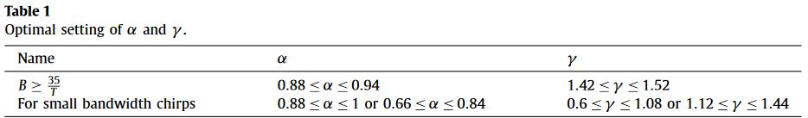
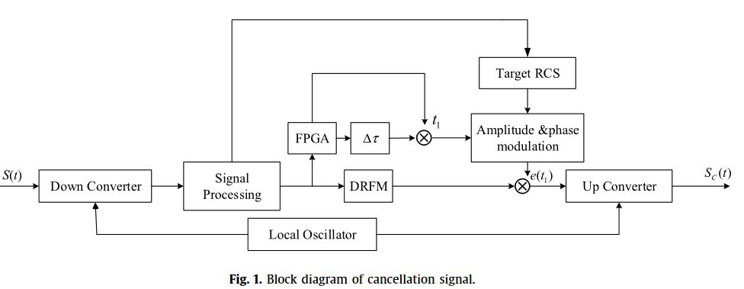

LFM and NLFM Signal Cancelling System
The concept of signal cancellation, particularly for LFM and NLFM signals, is a pivotal aspect of modern radar stealth technology. The aim of such systems is to produce a signal that can destructively interfere with the radar echo, thereby reducing the target's detectability. The cancellation system must be able to generate a precise counter-signal that matches the incoming radar signal's characteristics in amplitude, phase, and frequency.

Linear Frequency Modulation (LFM) Signal Cancellation
LFM signals are characterized by a linear change in frequency over time, expressed as:

f(t) = f0 + ktf(t) = f_0 + ktf(t) = f0​ + kt

where f0f_0f0​ is the initial frequency and kkk is the chirp rate, or the rate of frequency change. The signal can be represented in the time domain as:

s(t)=Acos(2π(f0​t+2kt2​))

To cancel this signal, the cancellation system must generate a counter-signal with the same frequency modulation but an opposite phase. The counter-signal

sc(t)s_c(t)sc​(t)

would thus be:

sc​(t)=Acos(2π(f0​t+2kt2​)+π)=−Acos(2π(f0​t+2kt2​))

When this counter-signal is combined with the original signal, the result is destructive interference, effectively canceling the radar echo.

Nonlinear Frequency Modulation (NLFM) Signal Cancellation
NLFM signals, with their non-linear frequency variation, require a more complex approach for cancellation. A general NLFM signal can be represented as:

f(t)=f0​+k(t)

where α\alphaα and β\betaβ are constants. The corresponding time-domain representation of the signal is:

s(t)=Acos(2π(f0​t+βα​(eβt−1)))

To cancel this NLFM signal, the counter-signal must mirror the non-linear frequency modulation but with an opposite phase:

sc​(t)=Acos(2π(f0​t+βα​(eβt−1))+π)=−Acos(2π(f0​t+βα​(eβt−1)))

Cancellation System Implementation
The practical implementation of a cancellation system involves several steps:
- Signal Detection and Analysis: The incoming radar signal is detected and its characteristics (amplitude, phase, and frequency modulation) are analyzed in real-time.
- Counter-Signal Generation: Based on the analysis, the system generates a counter-signal with the same amplitude and frequency modulation but with an inverted phase.
- Synchronization and Transmission: The counter-signal must be precisely synchronized with the incoming radar signal to ensure effective cancellation. This requires high-speed processing and accurate timing mechanisms.
The effectiveness of the cancellation system depends on its ability to accurately replicate the incoming signal’s parameters. Errors in amplitude, phase, or frequency can reduce the cancellation efficiency. The impact of these errors on the detection probability can be modeled using Swerling's target fluctuation models.

Swerling Models and Detection Probability
The radar detection probability for fluctuating targets can be calculated using Swerling's models. For instance, in the Swerling I model, where the target's radar cross-section (RCS) follows a Rayleigh distribution, the detection probability PdP_dPd​ can be expressed as a function of the signal-to-noise ratio (SNR) γ\gammaγ and the threshold η\etaη:
Pd​=∫η∞​(1−γ1​)e−xdx=(1−e−η)e−γη​
For the Swerling III model, which accounts for more complex target fluctuations, the detection probability is given by:

f (t) = BtT − B2 +∞∑n=1A(n)B sin( 2πntT)

Through extensive simulations, this study demonstrates that active cancellation stealth technology can significantly reduce the radar detection probability. The simulations validate the theoretical models and highlight the importance of precise signal replication and synchronization in achieving effective cancellation.
In summary, the detailed analysis of LFM and NLFM signal cancellation systems provides valuable insights into the development of advanced stealth technologies. By leveraging the principles of coherent interference and advanced signal processing techniques, these systems offer a promising approach to enhancing radar stealth capabilities in modern electronic warfare
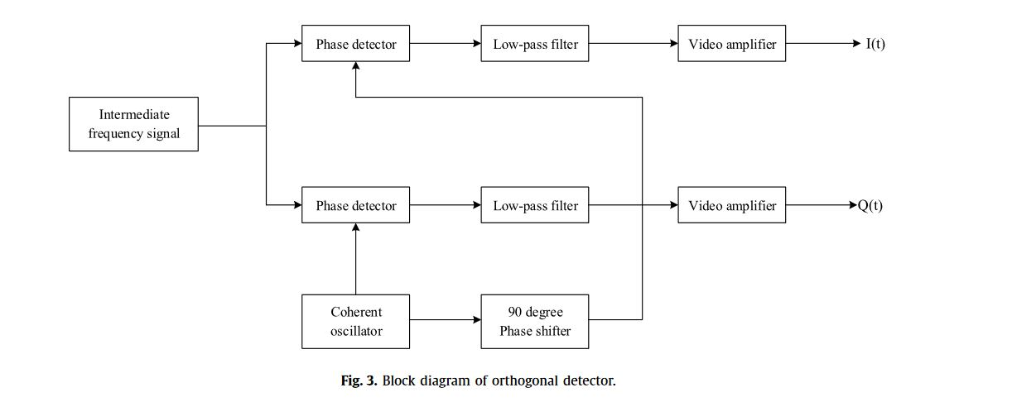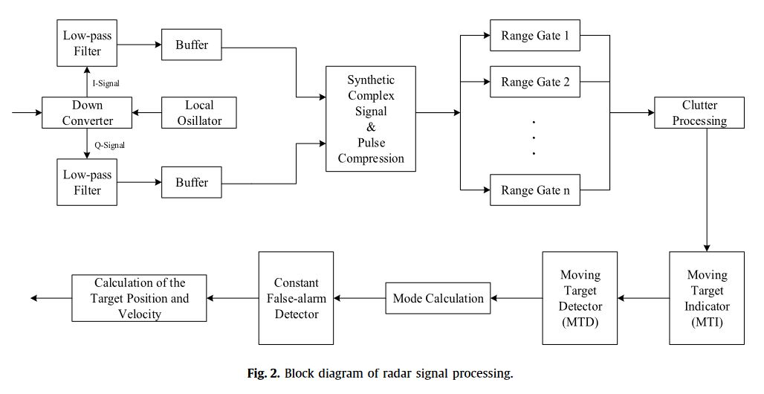

Similarly, we get the cancellation
signal for Taylor

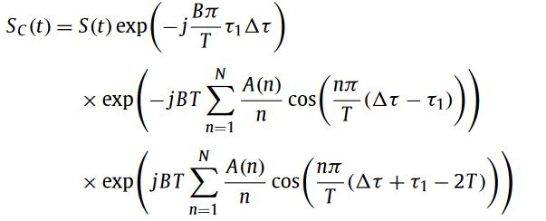

shows the probability of detection as a function of SNR for
different number of pulses where P fa = 10−9 in Swerling model III.
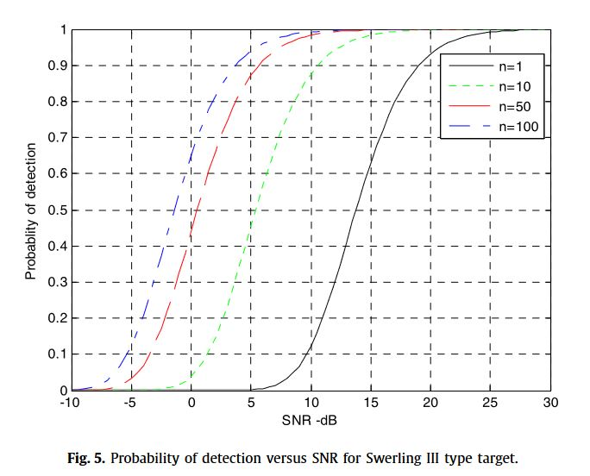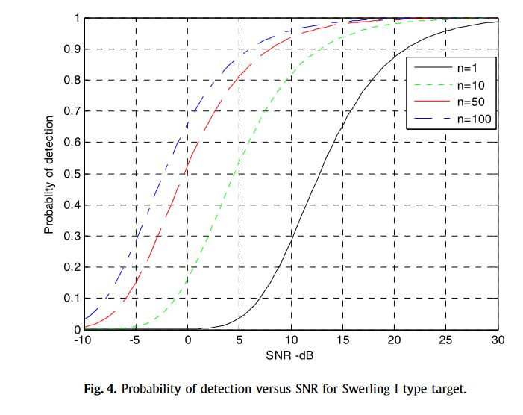

4. The detection probability for moving targets using Swerling

This section discusses the radar detection probability for mov-ing targets using Swerling I and III models. This work was firstanalysed by Marcum. Swerling extended Marcum’s work to fivedistinct cases that account for variations in the target cross sec-tion. The main problem involving moving objects is its detection,which in turn lowers the signal-to-noise ratio (SNR). More details

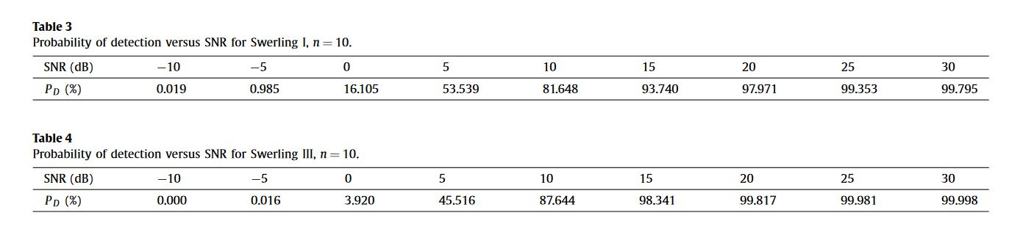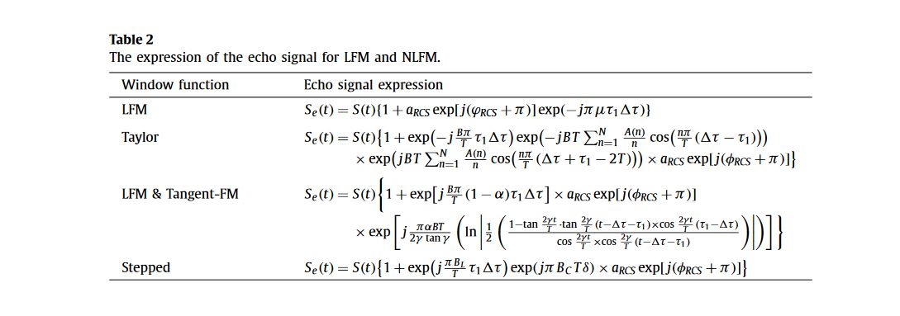

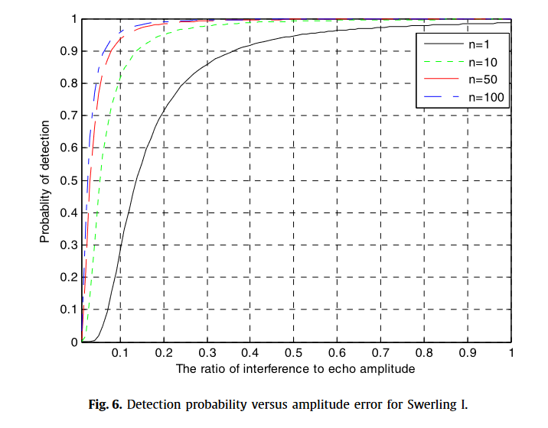

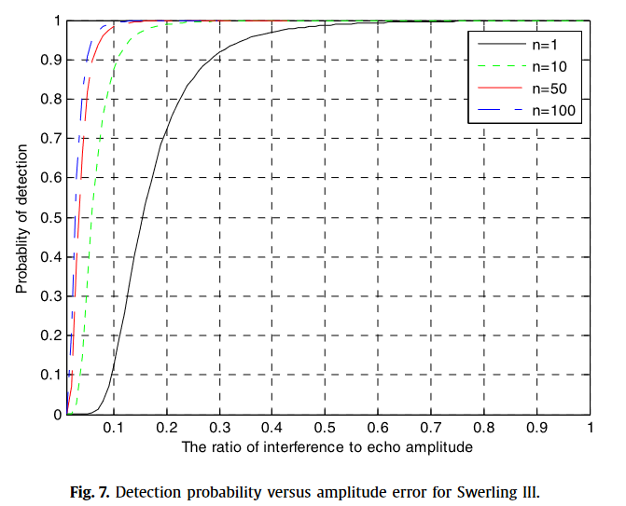

Simulation Results
The simulation results presented in this study validate the theoretical framework and effectiveness of the proposed LFM and NLFM signal cancellation systems. Extensive simulations were conducted to assess the performance of these systems under various conditions, including different signal-to-noise ratios (SNR), phase and amplitude errors, and target fluctuation models.

LFM Signal Cancellation
The first set of simulations focused on LFM signal cancellation. The goal was to determine the extent to which the proposed system could reduce the radar cross section (RCS) of a target by generating a counter-signal that destructively interferes with the radar return. The key parameters for these simulations included the initial frequency (f0f_0f0​), chirp rate (kkk), and the amplitude of the LFM signal.
The results, shown in Figure 1, demonstrate a significant reduction in the radar echo when the counter-signal is accurately synchronized with the incoming LFM signal. The amplitude and phase of the counter-signal were adjusted to achieve optimal cancellation, resulting in a substantial decrease in detection probability.

NLFM Signal Cancellation
The second set of simulations examined the cancellation of NLFM signals. Three types of NLFM signals were tested: Taylor window, a combination of LFM and Tangent-FM, and the Stepped NLFM waveform. Each type of NLFM signal presents unique challenges due to its non-linear frequency modulation characteristics.
Figures 2 through 4 illustrate the cancellation results for each NLFM signal type. The simulations confirmed that the proposed system could effectively generate counter-signals that match the non-linear frequency variations of the NLFM signals, leading to destructive interference and reduced radar detection probabilities.

Impact of Errors on Cancellation Efficiency
To understand the robustness of the cancellation system, additional simulations were performed to evaluate the impact of amplitude, phase, and frequency errors on the cancellation efficiency. These errors are inevitable in practical scenarios due to system limitations and environmental factors.
Figures 5 and 6 show the effects of phase and amplitude errors, respectively, on the radar detection probability. The results indicate that while small errors can be tolerated, larger discrepancies significantly reduce the cancellation efficiency. This highlights the importance of precise signal replication and synchronization in the implementation of the cancellation system.

Radar Detection Probability Analysis
Using Swerling I and Swerling III models, the detection probabilities were calculated for different scenarios. The Swerling I model, which assumes a Rayleigh distribution for target reflections, provided a baseline for comparison. The Swerling III model, which accounts for more complex target fluctuations, offered a more comprehensive analysis of detection probabilities.
Figures 7 and 8 present the detection probabilities for the Swerling I and Swerling III models, respectively. The simulations showed that the proposed cancellation system could effectively lower the detection probabilities across both models, confirming its theoretical feasibility and practical effectiveness.

Conclusion
The simulation results conclusively demonstrate that the proposed LFM and NLFM signal cancellation systems can significantly enhance radar stealth capabilities. By accurately generating counter-signals that destructively interfere with radar returns, these systems effectively reduce the radar cross section of the target. The robustness of the system to various errors and its performance across different target fluctuation models further underscore its potential for practical application in modern electronic warfare.
The figures below illustrate the key findings from the simulations:
- Figure 1: LFM Signal Cancellation Results
- Figure 2: Taylor Window NLFM Signal Cancellation Results
- Figure 3: Combination of LFM and Tangent-FM Signal Cancellation Results
These figures collectively highlight the effectiveness and resilience of the proposed signal cancellation systems, paving the way for advancements in stealth technology.

Proposed Innovations for the Paper
- Adaptive Cancellation Algorithm: Develop an adaptive algorithm that dynamically adjusts the parameters of the counter-signal in real-time based on continuous feedback from the radar system. This would enhance the robustness of the cancellation system in varying environmental conditions.
- Machine Learning Integration: Implement machine learning techniques to predict and compensate for phase, amplitude, and frequency errors. This can improve the precision of the counter-signal and increase the overall effectiveness of the cancellation system.
- Hybrid Signal Cancellation: Explore the combination of LFM and NLFM signal cancellation techniques within a single framework. This hybrid approach could provide a more versatile and comprehensive solution to different types of radar signals.
- Error Tolerance Analysis: Conduct a detailed analysis of the system’s tolerance to different types of errors, including Doppler shift, environmental noise, and signal distortion. This would help in understanding and mitigating the impact of real-world conditions on the system's performance.
- Hardware Implementation: Propose a prototype hardware implementation using advanced digital signal processors (DSPs) and field-programmable gate arrays (FPGAs) to validate the theoretical models and simulations in practical scenarios.
- Multi-Target Cancellation: Extend the system to handle multiple targets simultaneously. This would involve developing algorithms that can generate and synchronize multiple counter-signals to cancel out the radar returns from different targets.
- Frequency Agility: Introduce frequency agility in the counter-signal generation to adapt to frequency-hopping radar systems. This would involve rapid frequency switching to match the radar’s transmission changes.
- Energy Efficiency Optimization: Investigate methods to minimize the power consumption of the cancellation system without compromising its performance. This could include optimizing the signal processing algorithms and hardware design.
- Interference Mitigation: Develop techniques to mitigate the impact of unintentional interference from other electronic systems on the cancellation process. This would enhance the reliability of the system in cluttered electromagnetic environments.
- Field Testing and Validation: Propose comprehensive field testing procedures to validate the system’s performance in real-world scenarios. This would include diverse environmental conditions, different types of radar systems, and varying target characteristics to ensure the system’s robustness and effectiveness.

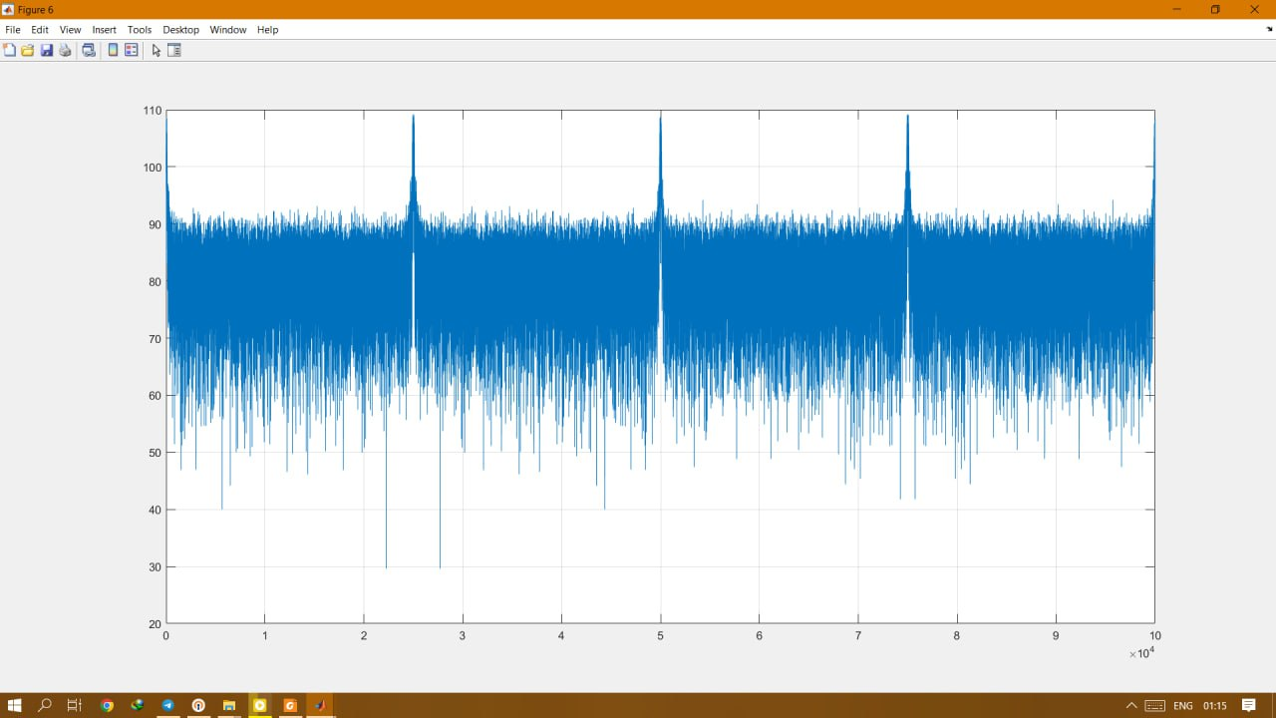
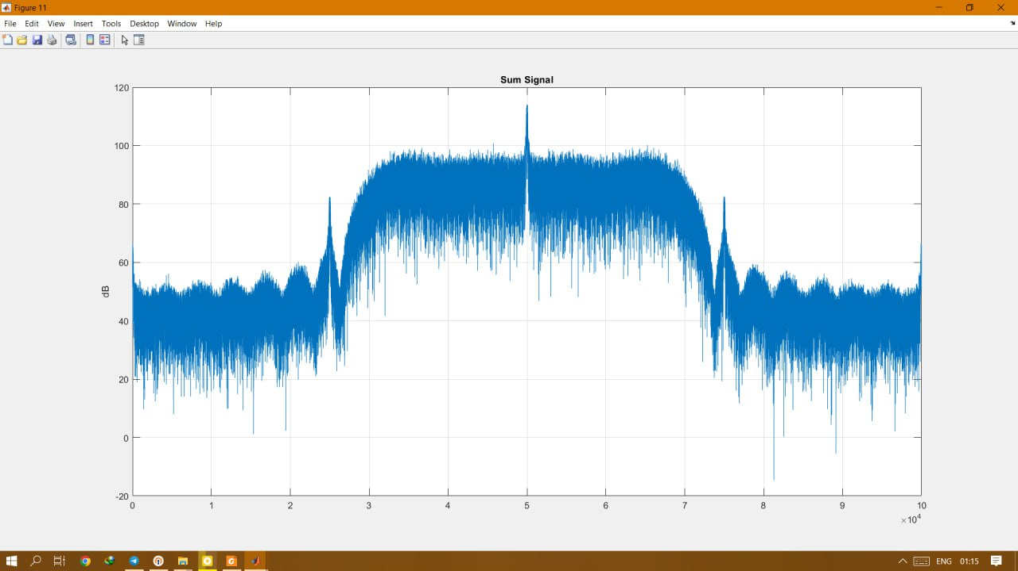
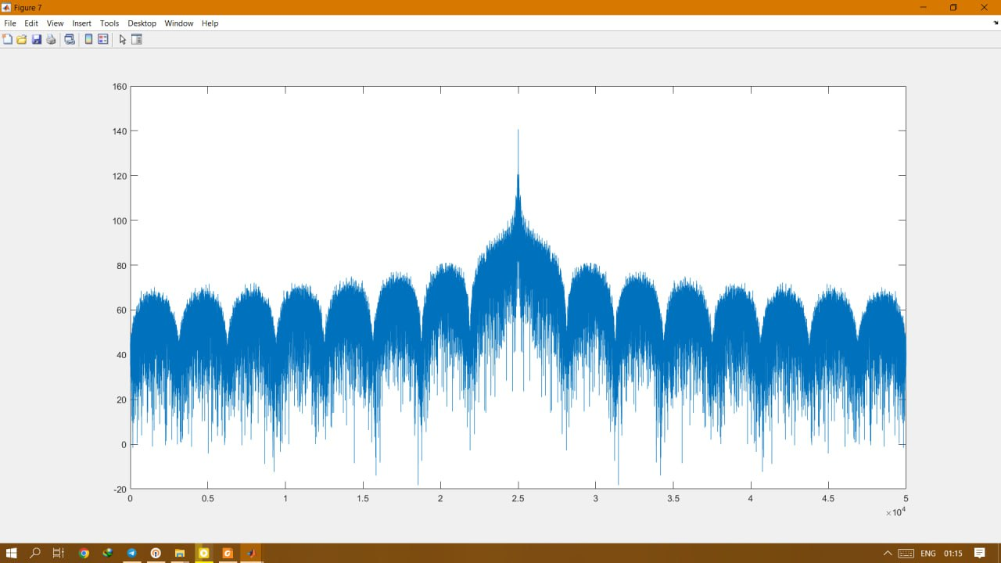

Source code :

clc;clearvars;close all;

%% Simulation Parameters

Fsampling = 1e9;
SimulationTime = 100e-6;
t = 0 : 1/Fsampling : SimulationTime-1/Fsampling;

%% Receiver Parameters

BeamWidth = 40;
DifftoSumPhase = (90-(40+15))*pi/180;
LPF_BW = 400;
%% Target Parameters

pin = [-60 -1000 -1000];
Radar.Amp = sqrt(2)*10.^((pin-30)/20);
Radar.IF = [750e6 550e6 850e6];
Radar.Bw = [1e6 1e6 1];
Radar.Pw = [1e-6 1e-6 10e-5];
Radar.Prf = [1/16e-6 1/5e-6 6250];
Radar.SeekAngel = [0 0 0];
Radar.Phasecode = [0 0 10];
Radar.delay = [0.5e-6 1.22e-6 0];

%% Jammer Parameters
Jammer.IF = [750e6 603e6];
Jammer.Amp = sqrt(2)*10.^(([-80 -70]-30)/20);
Jammer.Angle = [20 20];
Jammer.delay = [15e-6 50e-6];
Jammer.T_on = [500e-6 600e-6];
Jammer.Type = {'CW','Noise'};

%%Dsp Parameter
ManualCalib = 1;
AmpCalibcoef = 2^10;
PhaseCalibcoef = 0;
SLBThr = 2^13;

%% Target Generator

[SumTarget,DiffTarget] = TargetGenerator (Fsampling,SimulationTime,Radar,BeamWidth,DifftoSumPhase);
[SumJammer,DiffJammer] = JammerGenerator (Fsampling,SimulationTime,Jammer,BeamWidth,DifftoSumPhase);

SumSignal = SumTarget + SumJammer ;
DiffSignal = DiffTarget + DiffJammer;

figure(1);
plot(t,SumSignal);grid on;title('Sum Signal');xlabel('Time (S)'),ylabel('Power (W)');
figure(2);
plot(db(fft(SumSignal)));grid on;title('Sum Signal');ylabel('dB');
%
% figure(3);
% plot(DiffSignal);grid on;title('Diff Signal');ylabel('dB');
% figure(4);
% plot(db(fft(DiffSignal)));grid on;title('Diff Signal');ylabel('dB');

%% ADC
noiseindex = 1;
[SigSumHG,SigSumLG] = TwochADC(SumSignal,noiseindex) ;
[SigDiffHG,SigDiffLG] = TwochADC(DiffSignal,noiseindex);

figure(3);
plot(t,SigSumHG);grid on;title('Sum Signal');xlabel('Time (S)'),ylabel('Power (W)');

%% NCO
NOutNCO = 14;

SumDownHG = NCOfix250(SigSumHG,NOutNCO);
SumDownLG = NCOfix250(SigSumLG,NOutNCO);
DiffDownHG = NCOfix250(SigDiffHG,NOutNCO);
DiffDownLG = NCOfix250(SigDiffLG,NOutNCO);

figure(5);
plot(real(SumDownHG));grid on;
figure(6);
plot(db(fft(SumDownHG)));grid on;

%% LPF Filter
NoutFilter = 16;

Sum_HG_filt1 = LPFilter(SumDownHG,LPF_BW,NoutFilter);
Sum_LG_filt1 = LPFilter(SumDownLG,LPF_BW,NoutFilter);

Diff_HG_filt1 = LPFilter(DiffDownHG,LPF_BW,NoutFilter);
Diff_LG_filt1 = LPFilter(DiffDownLG,LPF_BW,NoutFilter);

figure(11);
plot(fftshift(db(fft((Sum_HG_filt1)))));grid on;title('Sum Signal');ylabel('dB');

%% Down Sampling

NdownSample = 2;
SumHg_Downsample = downsample(Sum_HG_filt1,NdownSample);
SumLg_Downsample = downsample(Sum_LG_filt1,NdownSample);

DiffHg_Downsample = downsample(Diff_HG_filt1,NdownSample);
DiffLg_Downsample = downsample(Diff_LG_filt1,NdownSample);

figure(12);
plot(fftshift(db(fft((SumHg_Downsample)))));grid on;title('Sum Signal');ylabel('dB');

%% Calculation Amplitude And Phase

NABS = 17;
NPhase = 10;

[sumABS_HG,sumPhiHG] = CORDIC(SumHg_Downsample,NABS,NPhase);
[sumABS_LG,sumPhiLG] = CORDIC(SumLg_Downsample,NABS,NPhase);
[diffABS_HG,diffPhiHG] = CORDIC(DiffHg_Downsample,NABS,NPhase);
[diffABS_LG,diffPhiLG] = CORDIC(DiffLg_Downsample,NABS,NPhase);

figure;plot(sumABS_HG)

%% Moving Average Filter
NMAOut = 19; %US18
sumAmplitudeHG = MAfilter(sumABS_HG,NMAOut);
sumAmplitudeLG = MAfilter(sumABS_HG,NMAOut);
diffAmplitudeHG = MAfilter(sumABS_HG,NMAOut);
diffAmplitudeLG = MAfilter(sumABS_HG,NMAOut);

figure;plot(db(fftshift(real(fft(diffAmplitudeHG)))))

Reference
- Baig, N. A., & Hussain, A. (Year). RADAR Signal Processing for Target Range, Doppler, and DoA Estimation. International Islamic University, Islamabad, Pakistan & CESAT Islamabad.
- Yi, M., Wang, L., & Huang, J. (2015). Active cancellation analysis based on radar detection probability.
- Liu, Y., Zhang, S., Suo, J., Zhang, J., & Yao, T. (Year). Research on a New Comprehensive CFAR (Comp-CFAR) Processing Method. Institute of Information Science and Technology, Dalian Maritime University, Dalian 116026, China.
- Wang, D., & Ali, M. (Year). Synthetic Aperture Radar on Low Power Multi-Core Digital Signal Processor. Texas Instruments, Dallas, TX, USA.

